**FLOWER SHOP MANAGEMENT SYSTEM**

*A PROJECT REPORT*

*Submitted by*

**M.KRISHNAVENI**

**(Reg No : 95072252018)**

**MASTERS IN**

**COMPUTER APPLICATIONS**

# ABSTRACT

Provided that spending budget is usually realistic for your bouquets that you want to obtain. Occasionally blending cheaper bouquets with the very same color as costly flowers may produce a lovely marriage ceremony present, and you will not just notice it is not every tulips or perhaps no matter what costly floral you needed. You should authenticate after which it re-verify the particular date that the blooms will probably be sent. You want those to possibly be new on your big day, but they will probably keep your marriage ceremony simple whenever they make an appearance late. Ensure that your chosen program can easily produce one of which time, at a proper occasion, when you make the invest in. This will likely decrease the actual disarray that will You are able to get beautiful blooms with no bursting your budget, provided that spending budget is usually realistic for your bouquets that you want to obtain. Occasionally blending cheaper bouquets with the very same color as costly provided that spending budget is usually realistic for your bouquets that you want to obtain. provided that spending budget is usually realistic for your bouquets that you want to obtain. You are able to get beautiful blooms with no bursting your budget, provided that spending budget is usually realistic for your bouquets that you want to obtain. blending cheaper bouquets with the very same color as costly lowers may produce a lovely marriage ceremony present, and you will not just notice it is not tulips or perhaps no matter what costly floral you needed.you should authenticate after which it re-verify the particular date that the blooms will proberly keep your marriage ceremony simple whenever they make an appearance late..

**INTRODUCTION**

E-commerce is the buying and selling of goods and services, or the transmitting of funds or data, over an electronic network, primarily the internet. These business transactions occur either as business-to-business (B2B), business-to-consumer (B2C), consumer-to- consumer or consumer-to-business.

## Characteristics

This software is capable of recording details of sales and purchase order.Similarly keeps track of expenses and income of the company. This billing accountingsoftware can be used to generate various reports including Item, Ledger, Sales order,Purchase order and Expenses ledger and more. This software is totally self containedand works relatively as efficient as other packages related to the subject. It providessimple database rather than complex ones for high requirements and it provides goodand easy graphical user interface to both new as well as experienced user of the computer.

# EXISITING SYSTEM AND PROPOSED SYSTEM

## Exisiting system

The exisiting system maintained the data manually. The personal details about the customers,download the picture,receipt details, stock, the transcation made with the customer in various place.

## Disadvantages

* Storing data and retrieval becomes very difficult
* It is not computerized and hence not systematic
* Same data are stored in more than one location
* Access speed is less for searching and modifiting data.
* products, offers, change in price

## Proposed system

This website is capable of recording details of sales and purchase order. This website is totally self contained and works relatively as efficient as other packages. This website is totally self contained and works relatively. This website is totally self contained and works relatively as efficient as other packages related to the subject. It provides good and easy graphical user interface to both new as well as experienced user of the computer.

## Advantages:

* Expense become less
* Security is assured
* Stored data and procedurs can be easily edited
* Easy report generation
* Less manpower required

# Flow diagram

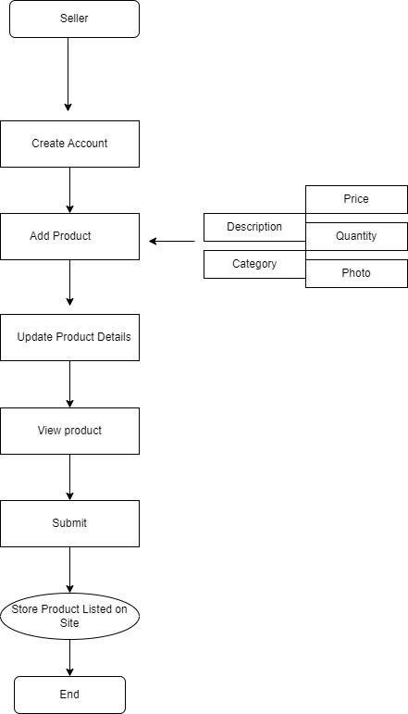

**HTML**

# Working environment

HTML is at the core of every web page, regardless the complexity of a site or number of technologies involved. It's an essential skill for any web professional. It's the starting point for anyone learning how to create content for the web. And, luckily for us, it's surprisingly easy to learn.

## CSS

CSS stands for Cascading Style Sheets. This programming language dictates how the HTML elements of a website should actually appear on the frontend of the page. HTML provides the raw tools needed to structure content on a website.

## Javascript

JavaScript is a more complicated language than HTML or CSS, and it wasn't released in beta form until 1995. Nowadays, JavaScript is supported by all modern web browsers and is used on almost every site on the web for more powerful and complex functionality.

# Output screen

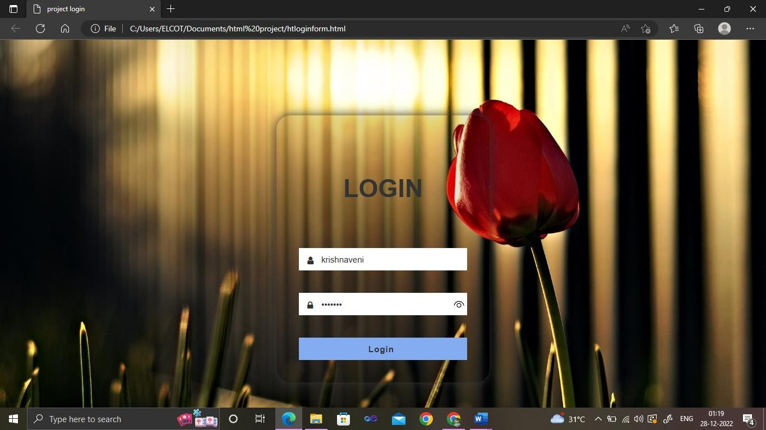

## Figure : 1 Login form

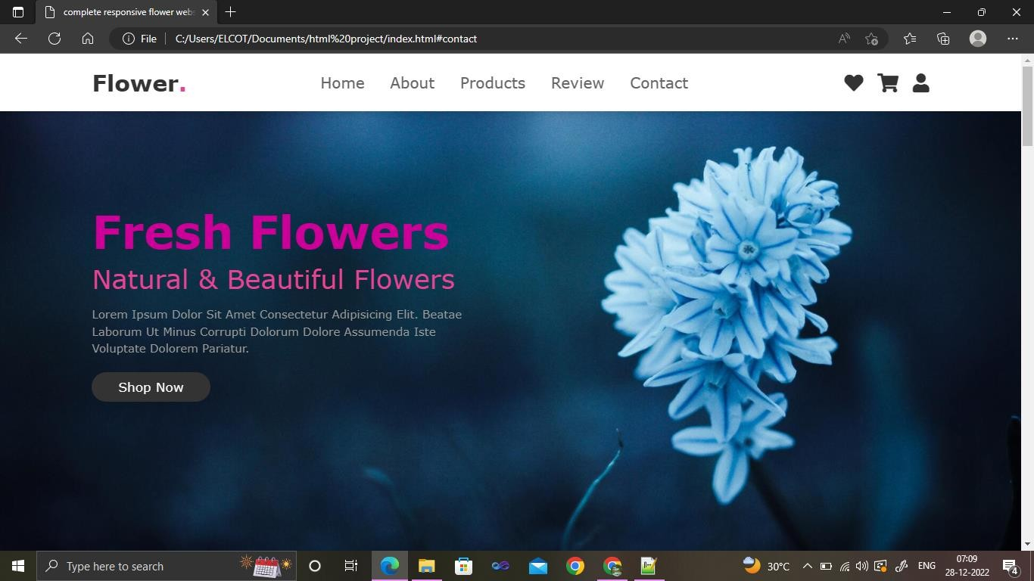

**Figure 2 : Index page**

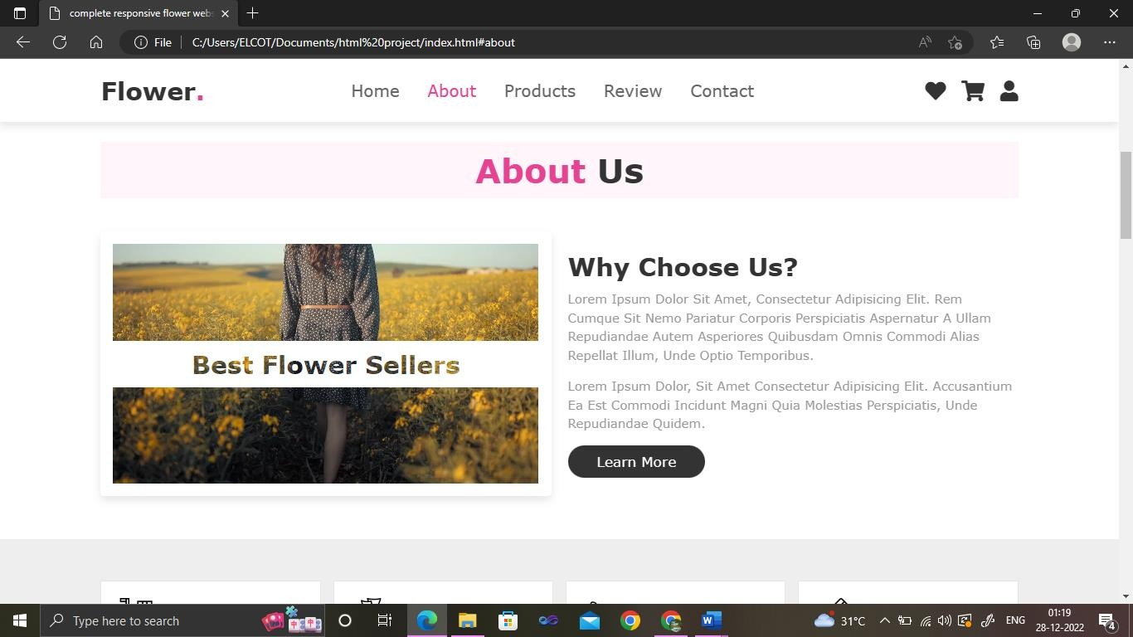

## Figure 3 : About page

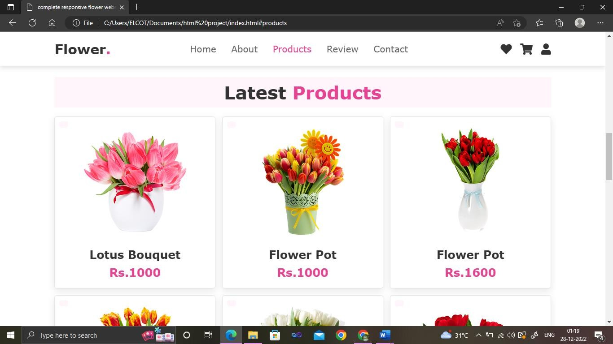

**Figure 4 : Products page**

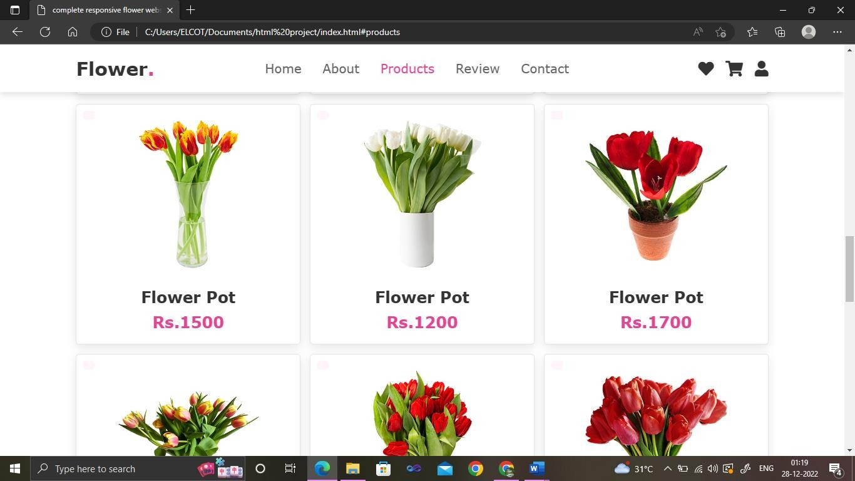

## Figure 5 : Products page

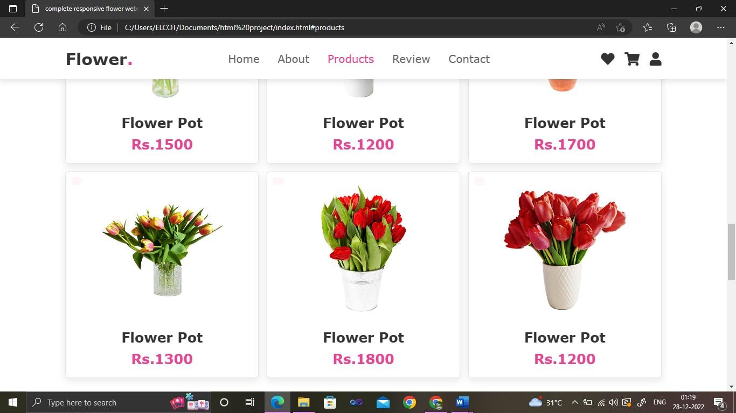

**Figure 6 : Products page**

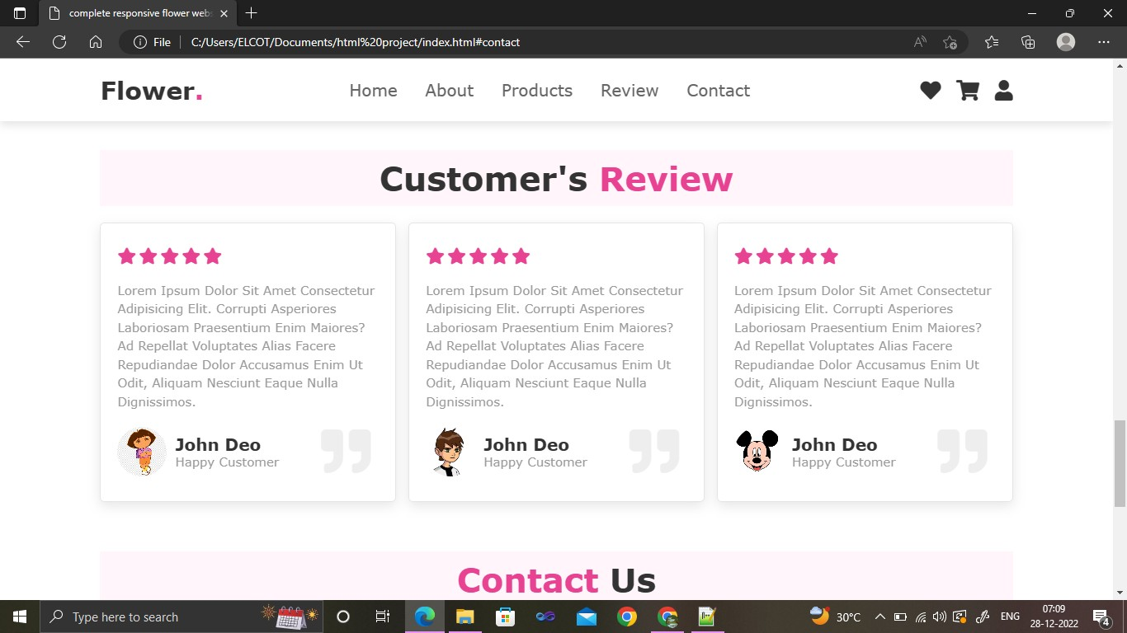

## Figure 7 : Review page

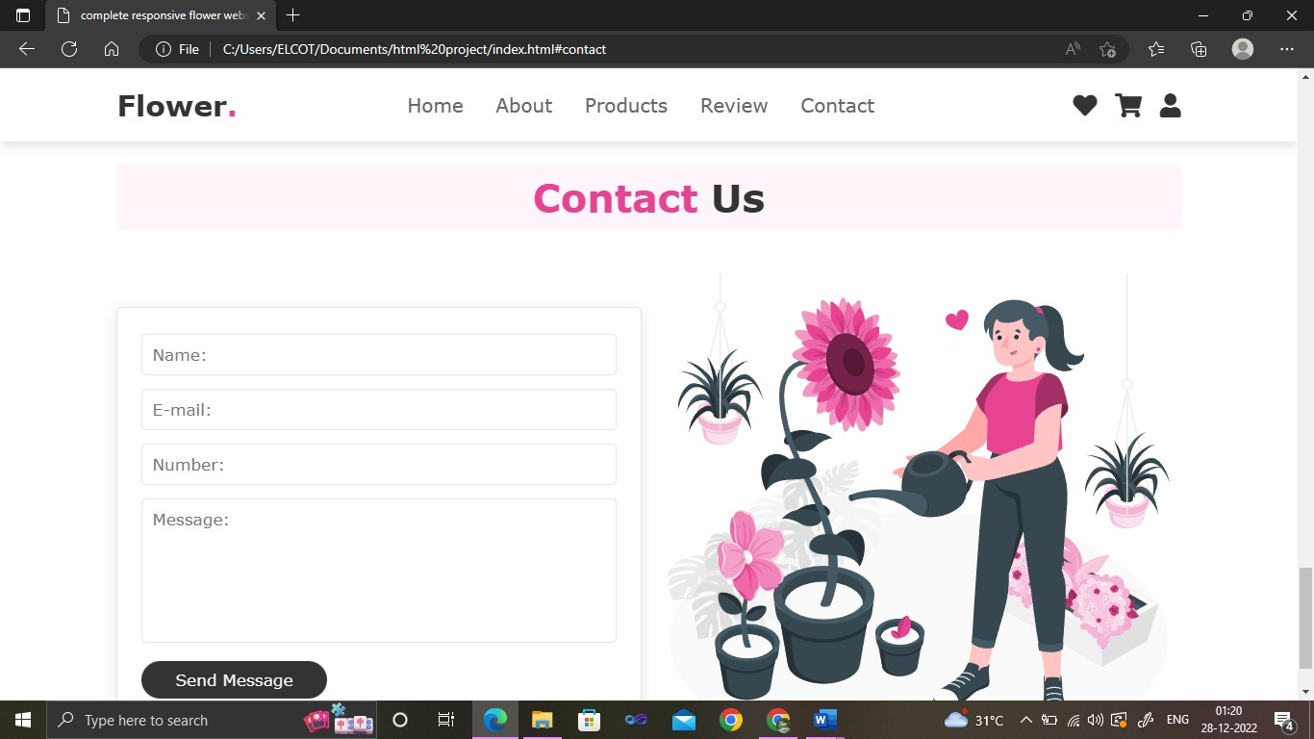

**Figure 8 : Contact page**

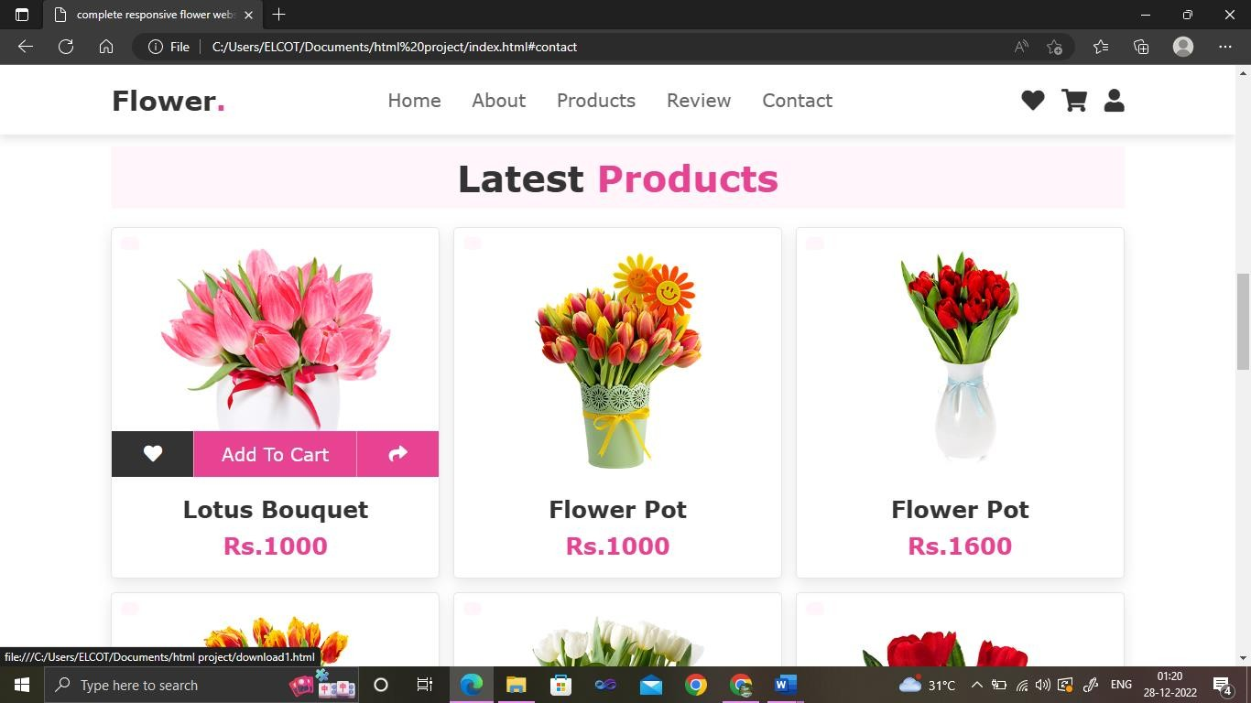

## Figure 9 : View page

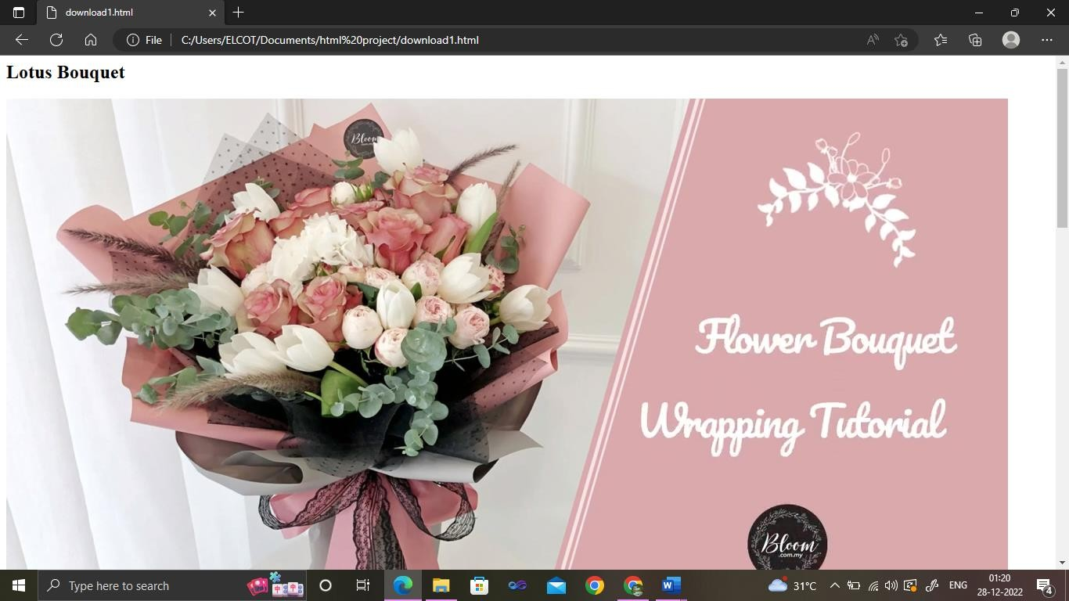

**Figure 10 : Specific product page**

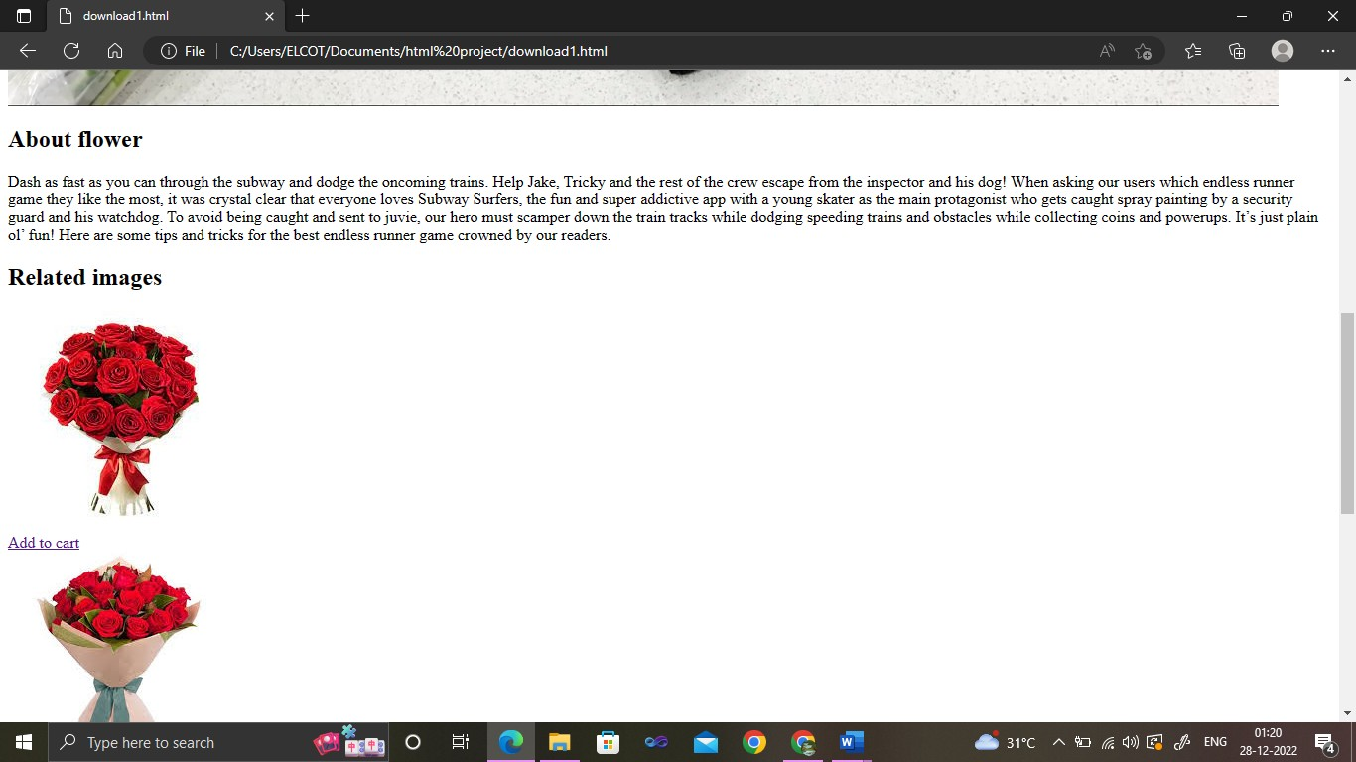

## Figure 11 : Specific product view page

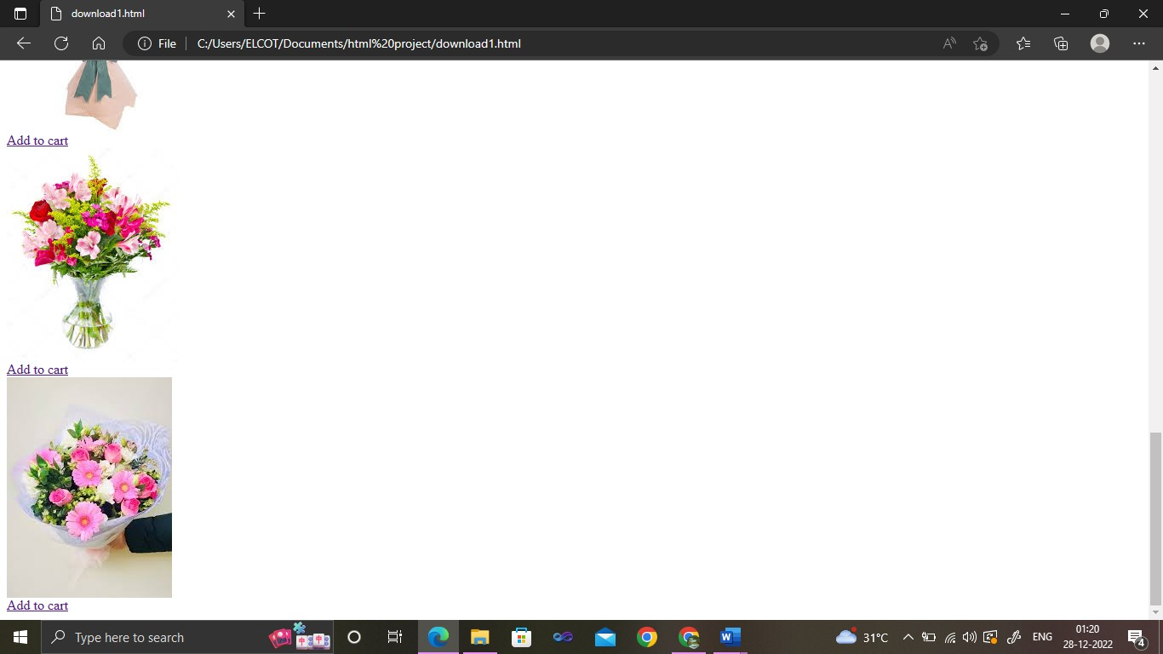

**Figure 12 : Specific product view page**

# Conclusion

This flower shop management system avoides the manual work and the problems concern with it.It is easy way to obtain the information regarding the various products information that is present in the markets.This system is an improved application better then the existing one’s regarding the information about the various activities. When we request information about particular details is shows all the relavant information. Ensure that your chosen program can easily produce one of which time, at a proper occasion when you make the invest in.this will likely decrease the actual disarray that will encompass the big day. Flower delivery business has become revolutionary in the delivery industry as it serves your customers with fresh flowers and magnifies your business revenue.

# Future enchancement

In the future the website will enhance. Website will more user-friendly. In future we will provide direct UPI payments. The website will be more secure and updated. In future we will add the voice search option. There is a comprehensive scope for floral businesses in the United States and other countries. Flowers are predominantly becoming one of the fastest-growing commodities in society because of their emotional and religious significance. Some of the leading flower delivery apps such as UrbanStems, Farmgirl flowers, and Bouqs are the top-notch of fower delivery business and are generating a decent amount of revenue to scale up their online flower delivery services.

# Reference

<https://nkc.ac.in/uploaded_files/1.3.4_STDNTPRJ_CS_P_10.pdf>

[https://www.studocu.com/in/document/madurai-kamaraj-university/bca/online-flower-](https://www.studocu.com/in/document/madurai-kamaraj-university/bca/online-flower-shop-final/27608445) [shop-final/27608445](https://www.studocu.com/in/document/madurai-kamaraj-university/bca/online-flower-shop-final/27608445)

[https://www.researchgate.net/publication/327335056_Development_of_Intelligent_Flow](https://www.researchgate.net/publication/327335056_Development_of_Intelligent_Flower_Shop_Management_System_Based_on_MIS) [er_Shop_Management_System_Based_on_MIS](https://www.researchgate.net/publication/327335056_Development_of_Intelligent_Flower_Shop_Management_System_Based_on_MIS)

https://sell.amazon.com/learn/what-is- ecommerce#:~:text=Ecommerce%20or%20electronic%20commerce%20is,ones%20on% 20the%20internet%20superhighway